Project of Course ITCS 6162/8162 Knowledge Discovery in Database

ActionRule

User Manual

Team Member: Jinfeng Du 800815618

Shanzhen Gao 800781807

Table of Contents

**1.** **The basic of the ActionRule Algorithm** 3

**2.How to Use the Software** 3

**About the Term Project** 6

# **The basic of the ActionRule Algorithm**

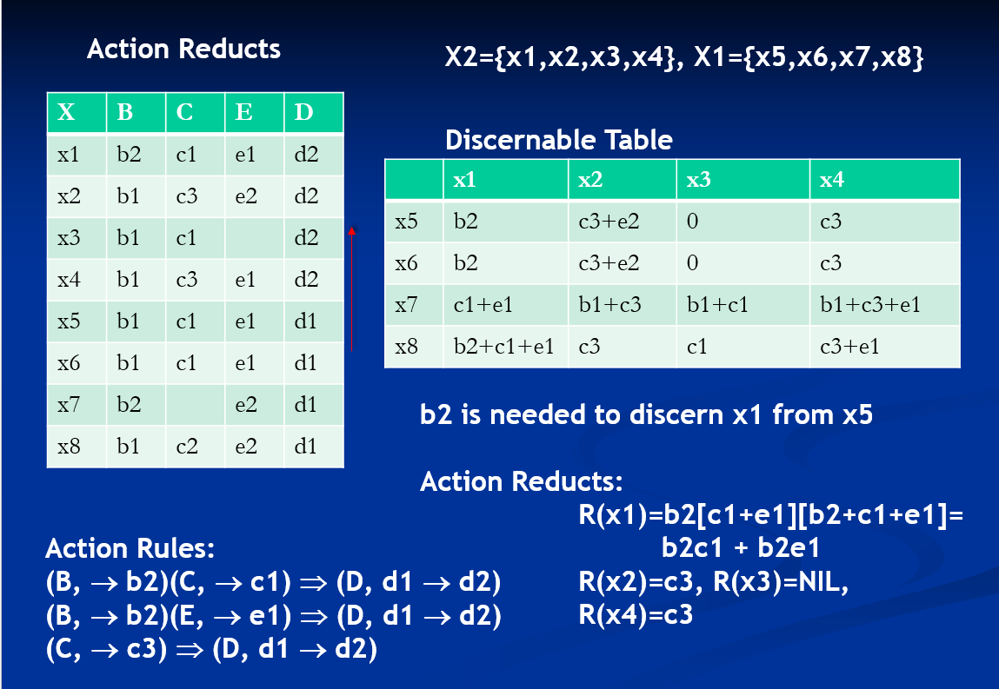

Follow the procedure in the slide above, we can Action Rules.

# **2.How to Use the Software**

Step 1:

Unzip the uploaded zip file and open the readme.txt file to have a basic understanding of the software.

Step 2:

Open the runnable jar file: ActionRule.jar

(To run the file, you need Java JRE installed. Please follow the instruction in the readme.txt)

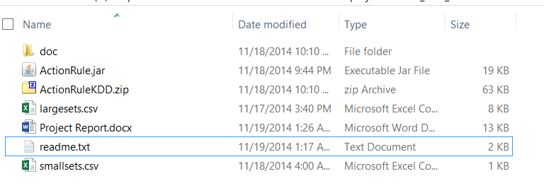

Step 3:

Click “**open a File”** to choose data file. (You can click “**about”** to see the instruction as well).

Choose the data file in .csv format in the project folder.

In the folder, the authors provided two files: largesets.csv and smallsets.csv. You can tell the difference based on the name.

(If you want to know the detailed data format of .csv file required, please go to the readme.txt file.)

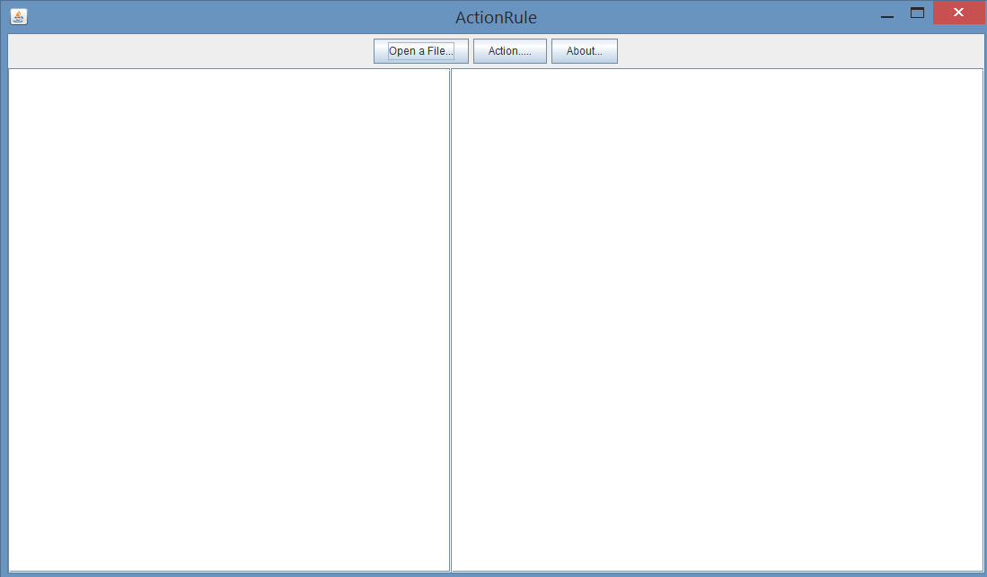

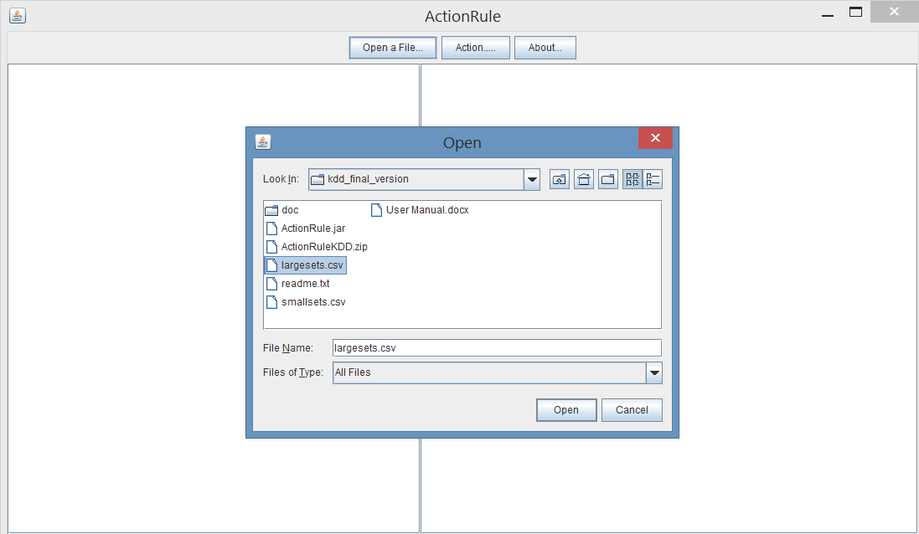

Step 4:

After you open the file. The content of the file will be displayed in the left text area. Then click “**Action**” Button to implement the Action Rule Algorithm on the data you just uploaded.

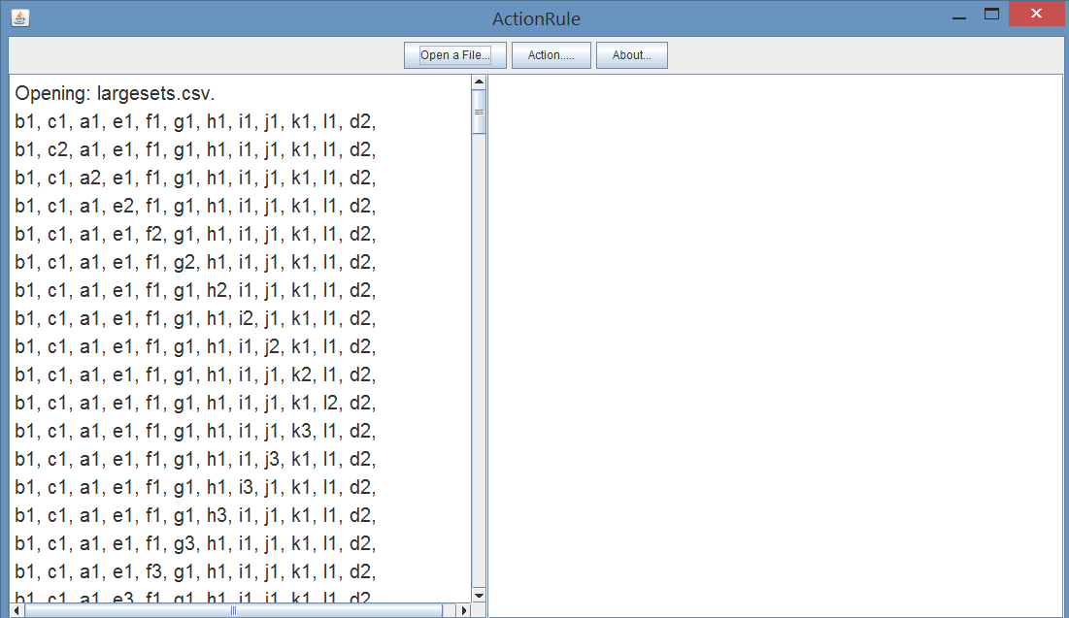

Step 5:

Congratulations! You get the action rules. The result will be displayed at the right text area.

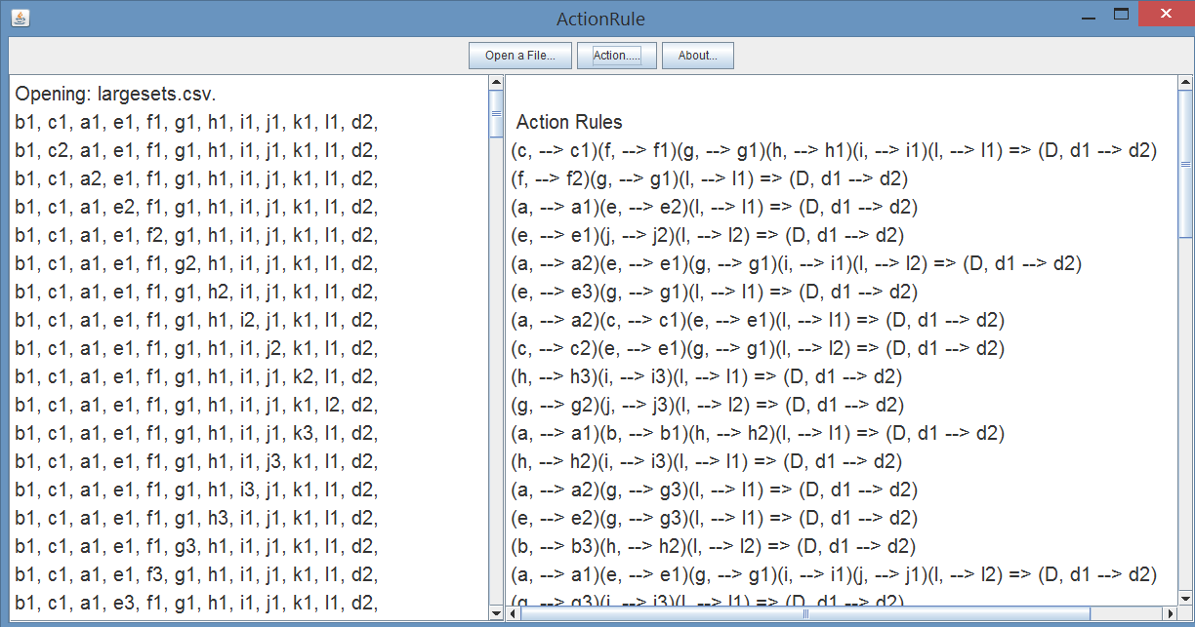

# **About the Term Project**

**Term project requirement:**

Implement the algorithm for discovering action reducts (described in the Paper) and then the algorithm or discovering action rules directly from action reducts. You can use your own dataset which has minimum 10 attributes and 200 rows. Otherwise you can use Failed States Index (FSI) Data [http://ffp.statesindex.org/rankings-2014]. If you decide to use FSI data, you should discretize them by replacing number n.k by n+1 if k>5 and by n if k < 6. The last column replace by Alert, Warning, Stable, Sustainable. All listed attributes are flexible so you have to add minimum two stable attributes (for instance: population, number of neigbours having equal or lower stability index). Submit your project with proper documentation (user manual) to "nedunuri@uncc.edu" and "ras@uncc.edu" not later than November 20, 2014.

**The Paper:**

“Action Reducts” by Seunghyun Im , Zbigniew Ras, Li-Shiang Tsay

It is an interesting paper.

Abstract of the paper. An action is defined as controlling or changing some of attribute values in an information system to achieve desired result. An action reduct is a minimal set of attribute values distinguishing a favorable object from other objects. We use action reducts to formulate necessary actions. The action suggested by an action reduct induces changes of decision attribute values by changing the condition attribute values to the distinct patterns in action reducts.

Keywords of the paper: Reduct, Action Reduct, Prime Implicant, Rough Set.

**About the format of datasets that we are using:**

Data object-attribute matrix

|  |  |  |  |  |  |  |  |  |  |  |  |
| --- | --- | --- | --- | --- | --- | --- | --- | --- | --- | --- | --- |
| Xi\jY | 1 | 2 | 3 | 4 | 5 | 6 | 7 | 8 | 9 | 10 | D |
| 1 | 2 | 1 | 1 | 1 | 1 | 1 | 1 | 1 | 1 | 3 | 2 |
| 2 | 2 | 2 | 1 | 1 | 2 | 1 | 1 | 1 | 1 | 1 | 2 |
| 3 | 2 | 1 | 1 | 1 | 1 | 2 | 1 | 1 | 1 | 2 | 2 |
| 4 | 1 | 1 | 1 | 1 | 1 | 1 | 1 | 1 | 1 | 1 | 1 |
| 5 | 1 | 1 | 2 | 1 | 1 | 1 | 1 | 1 | 1 | 1 | 1 |
| 6 | 2 | 1 | 1 | 1 | 2 | 3 | 1 | 1 | 1 | 3 | 1 |

Data object IDs are in the first column: X1, X2, X3,….

Decision Attribute is in the last column. We have decision d1 and d2.

Data attribute IDs are in the first row: 1Y,2Y,3Y, …..

For example: Consider the above data matrix. There are 6 data IDs: X1,X2,X3,X4,X5,X6. There are 10 attributes: 1Y,2Y,3Y3,4Y,5Y,6Y,7Y,8Y,9Y,10Y. There are 3 data object IDs with decision attribute value 2 and three data object IDs with decision attribute value 1. Look at the attribute values of attribute 5Y: X1 is 5Y2, X2 is 5Y3, X3 is 5Y1, X4 is 5Y1,X5 is 5Y2, and X6 is 5Y1. The last column is the decision attribute values: X1 is d2,X2 is d2,X3 is d2,DX4 is d1,X5 is d1,X6 is d1.

If the datasets are not in our required format, we train them into the format we need.

**Divide the Data-Object-Attribute Matrix into Matrix One and Matrix Two**

According to the decision values of the data objects, we make two matrices: the first matrix contains data objects with decision value d2. The second matrix contains data objects with decision value d1.

Data object-attribute matrix one (objects with decision attribute value 2):

|  |  |  |  |  |  |  |  |  |  |  |  |
| --- | --- | --- | --- | --- | --- | --- | --- | --- | --- | --- | --- |
| Xi\jY | 1 | 2 | 3 | 4 | 5 | 6 | 7 | 8 | 9 | 10 | D |
| 1 | 2 | 1 | 1 | 1 | 1 | 1 | 1 | 1 | 1 | 3 | 2 |
| 2 | 2 | 2 | 1 | 1 | 2 | 1 | 1 | 1 | 1 | 1 | 2 |
| 3 | 2 | 1 | 1 | 1 | 1 | 2 | 1 | 1 | 1 | 2 | 2 |

Data object-attribute matrix two (objects with decision attribute value 1):

|  |  |  |  |  |  |  |  |  |  |  |  |
| --- | --- | --- | --- | --- | --- | --- | --- | --- | --- | --- | --- |
| Xi\jY | 1 | 2 | 3 | 4 | 5 | 6 | 7 | 8 | 9 | 10 | D |
| 4 | 1 | 1 | 1 | 1 | 1 | 1 | 1 | 1 | 1 | 1 | 1 |
| 5 | 1 | 1 | 2 | 1 | 1 | 1 | 1 | 1 | 1 | 1 | 1 |
| 6 | 2 | 1 | 1 | 1 | 2 | 3 | 1 | 1 | 1 | 3 | 1 |

**To construct a Discernable Table/Matrix:**

Without loss of generality, we suppose that there are M rows in Matrix One, and N rows in Matrix Two. Then the size of the Discernable Matrix is M by N.

To get the (i,j)-th entry in the Discernable matrix: We compare Xi (the i-th row in Matrix Two) with Xj (the j-th row inMatrix One):

If all of the attributes values are the same, the (i,j)-th entry is (Ø). If only one attribute differs, say Xj is vYa and Xi is vYb, the (i,j)-entry is (vYa). If three are two or more attributes differ, then the (i,j)-entry is the sum of the attribute values of Xj. For instance Xj is vYa , uYc ,gYe and X(k+i) is vYb, uYd,gYf, then the (i,j)-entry is (vYa +uYc+gYe).

|  |  |  |  |
| --- | --- | --- | --- |
|  | X1 | X2 | X3 |
| X4 | 1Y2+10Y3 | 1Y2+2Y2+5Y2 | 1Y2+6Y2+10Y2 |
| X5 | 1Y2+3Y1+10Y3 | 1Y2+2Y2+3Y1+5Y2 | 1Y2+3Y1+6Y2+10Y2 |
| X6 | 5Y1+6Y1 | 2Y2+6Y1+10Y1 | 5Y1+6Y2+10Y2 |

To get Action Reducts from the Discernable Table/Matrix:

For 1=<i=<k, R(Xi)=simplification of the product of the entries in the i-th column in the matrix.

Simplification rules: a*(b+a)=a, Ø*a=Ø, a*a=a.

R(X1)=( 1Y2+10Y3)*( 1Y2+3Y1+10Y3)*( 5Y1+6Y1)

=(1Y2+10Y3)*(5Y1+6Y1).

=(1Y2)*(5Y1)+(1Y2)*(6Y1)+(10Y3)*(5Y1)+(10Y3)*(6Y1)

R(X2)=( 1Y2+2Y2+5Y2)*( 1Y2+2Y2+3Y1+5Y2)*( 2Y2+6Y1+10Y1)

=(2Y2+1Y2+5Y2) *( 2Y2+6Y1+10Y1)

=2Y2+(1Y2+5Y2) *( 6Y1+10Y1)

=2Y2+(1Y2)*(6Y1)+(1Y2)*(10Y1)+(5Y2)*(6Y1)+(5Y2)*(10Y1)

R(X3)=( 1Y2+6Y2+10Y2)*( 1Y2+3Y1+6Y2+10Y2) *(5Y1+6Y2+10Y2)

=( 1Y2+6Y2+10Y2)* (5Y1+6Y2+10Y2)

=(1Y2)* (5Y1+6Y2+10Y2)+ 6Y2+10Y2

=(1Y2)*(5Y1)+(1Y2)*(6Y2)+(1Y2)*(10Y2)+6Y2+10Y2.

Getting Action Rules from R(Xi):

If R(Xi)=Ø, there is no Action Rules from R(Xi).

If R(Xi)=vYa, then we can get one action rule: (Y, →vYa) implies (D,d1→d2).

If R(Xi)=sum of m terms after the simplification. Then there is one rule according to one term. For instance, one tern in the sum: (1Y2)*(5Y3)(7Y1), then the Action Rule is

(1Y, →1Y2) (5Y→5Y3) (7Y→7Y1) implies (D,d1→d2).

It is important to simplify the Discernable Table

We can use the Discernable table, to build a NEW simplified Discernable Table without any redundancy

It is important to make sure there is no duplicated action rules.

Measuring the usability of α-reduct:

Frequency, hit ratio, weight are important measurements.

By the way, it seems to us there is a typo in the paper: the summation of (f.g) = 3.5 (not 4). We also can see from Table 5 in the paper.